**Admin DashBoard:**

**Step 1:**

Taking admin dashboard code from github and using it in our vs code

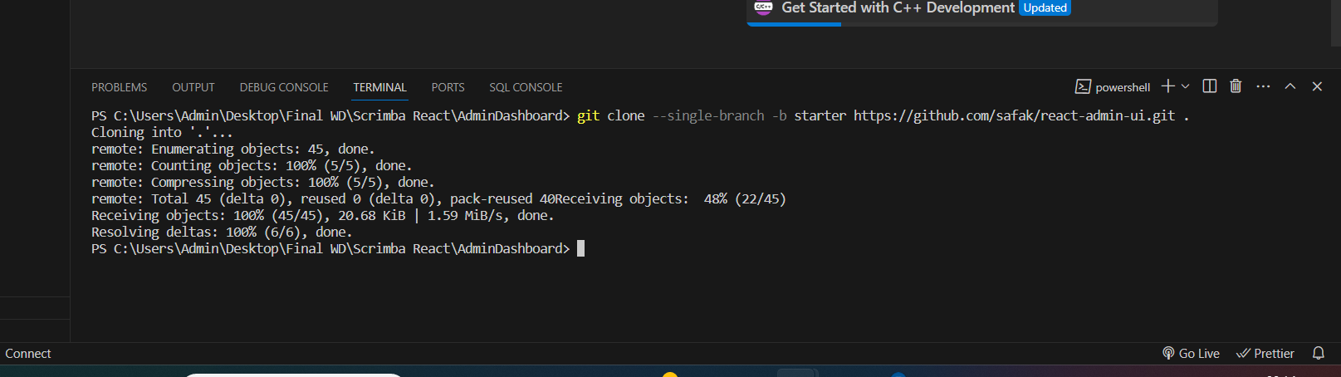

**Step 2:**

Npm I (to strat our application)

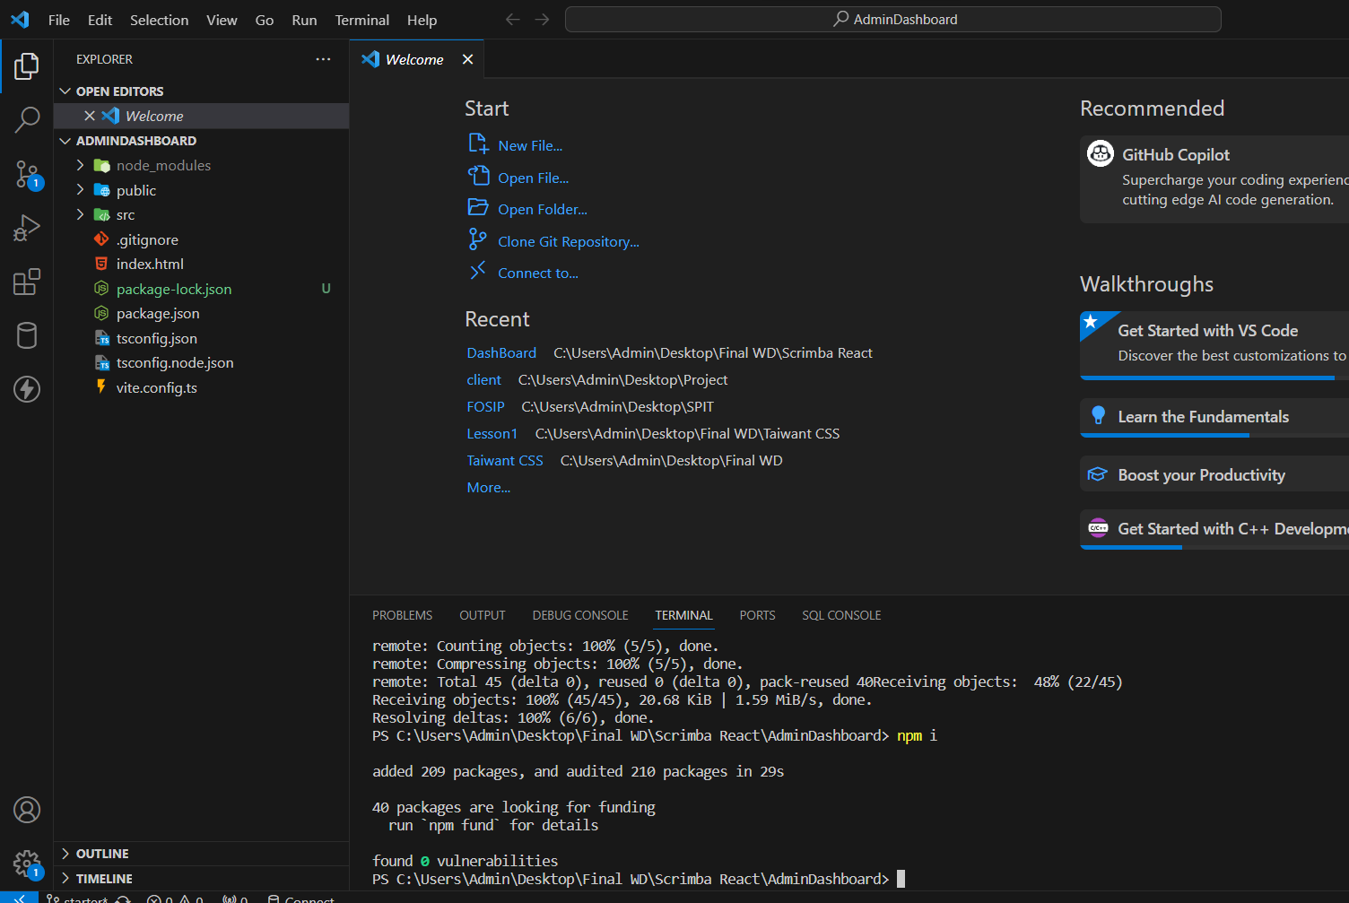

So we can see that package.json is ready and now we can start our application

**Step 3:**

Npm run dev

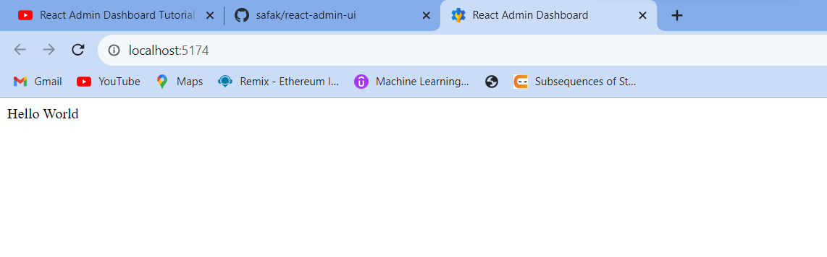

**Step 4:**

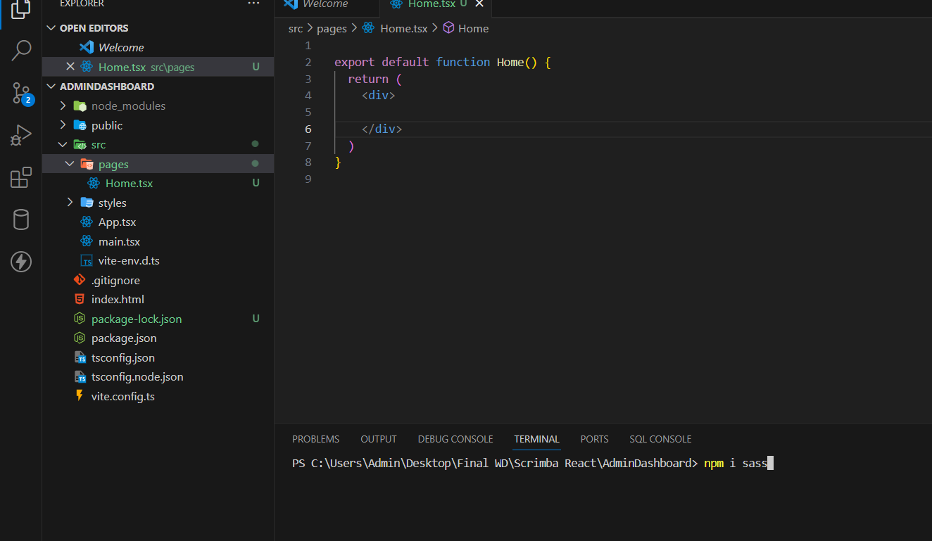

Creating Home.tsx and to add styling we used npm i sass

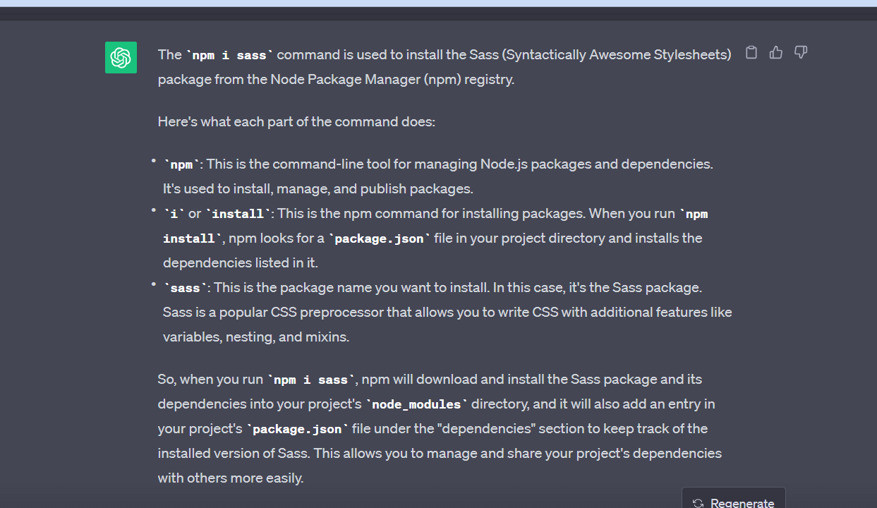

**Step 5:**

Checking how scss is working:

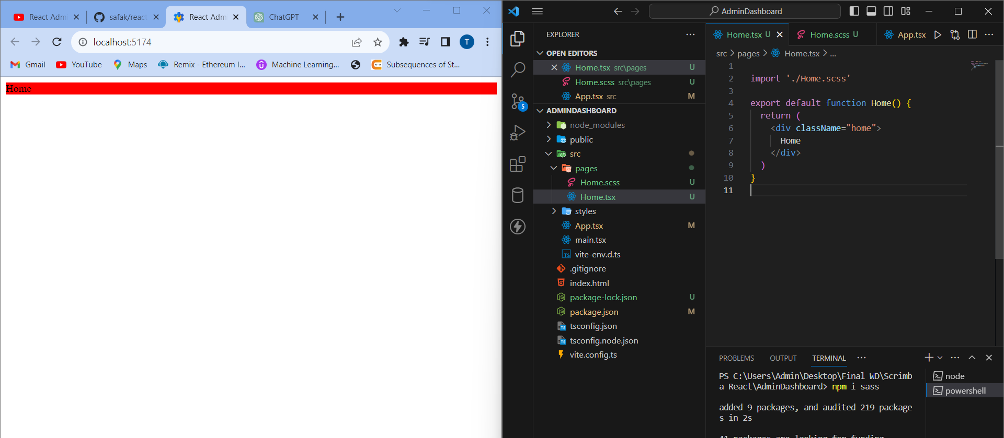

So Similarly we created all these pages:

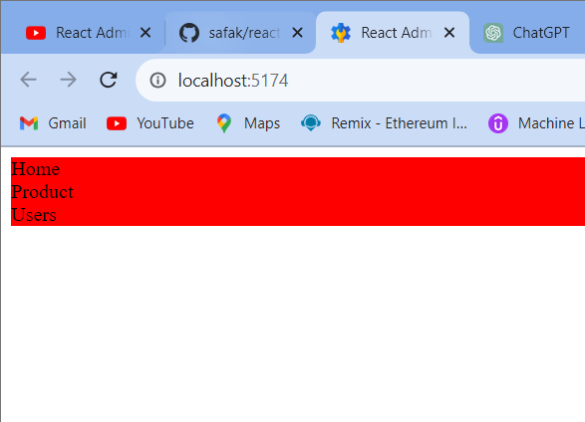

**Step 6:**

Using react router dom for navigating between different pages:

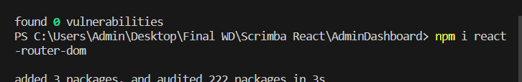

So basically see how routers are created

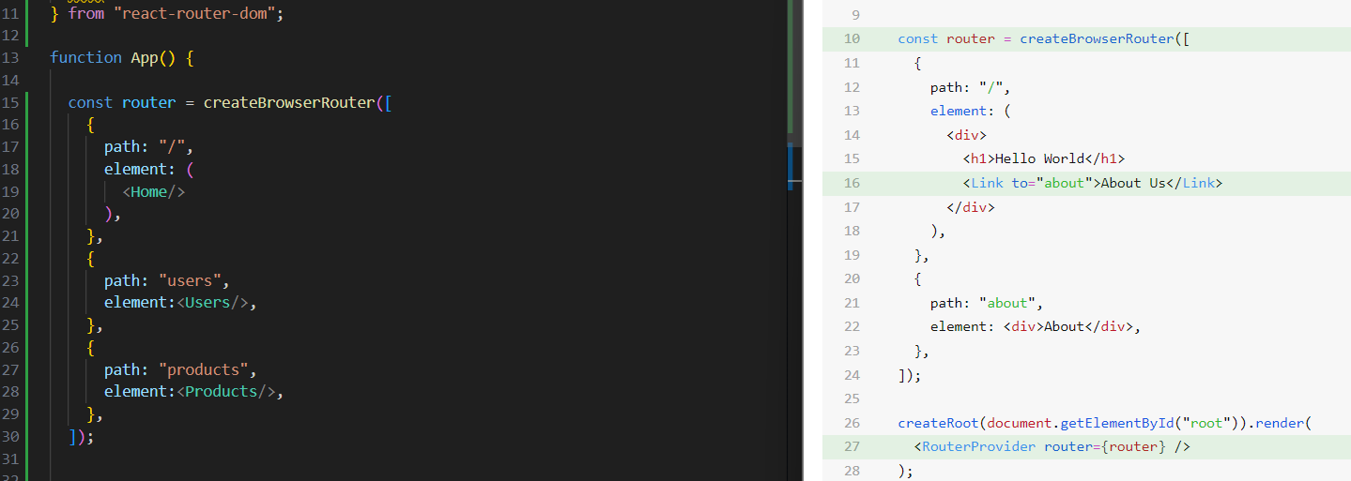

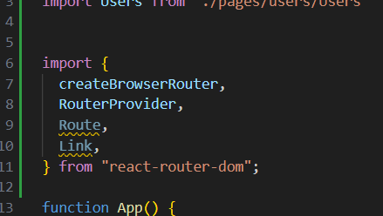

Also we need to pass these

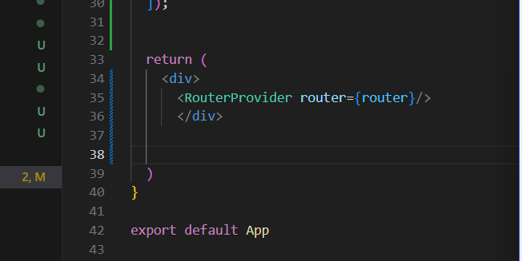

So this is the method of making routers

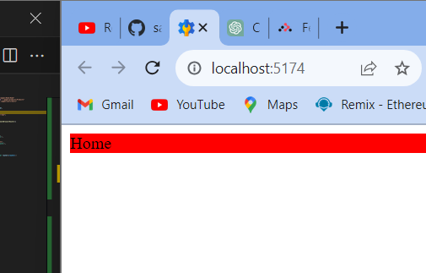

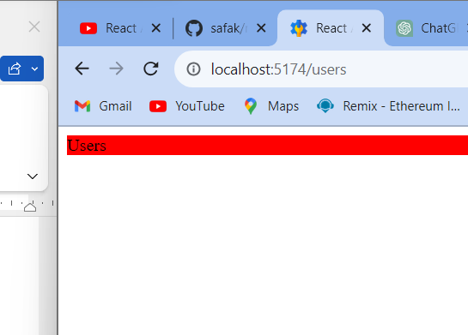

We have even checke and found that it is working

**Step 7:**

Creating Layout:

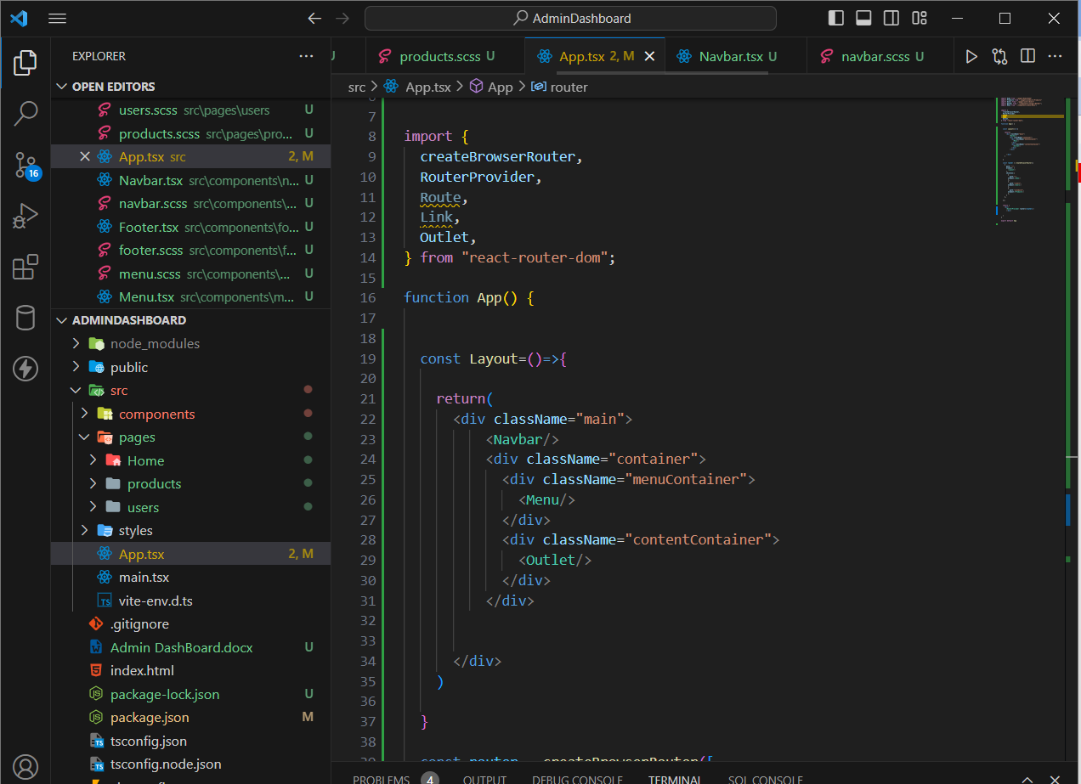

So firstly we created few components which u can observe

Now we will be creating our Layout

Also we used <Outlet/> here which we need to import from react router dom

So depending upon the route passed the outlet will be substituted

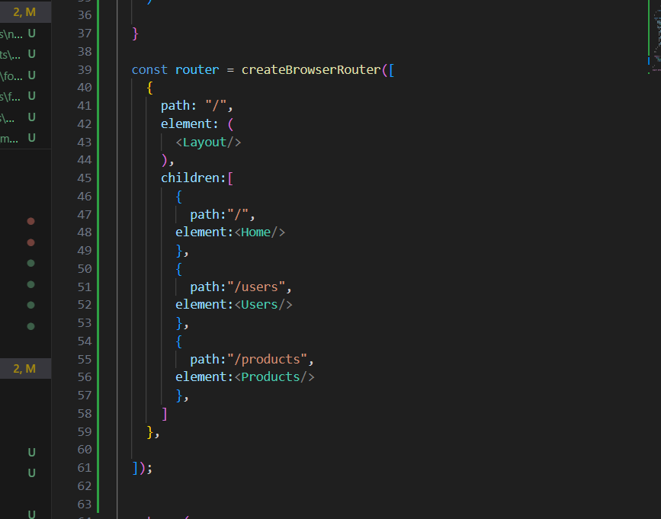

Note that this layout will be applicable only to children of this parent

So make sure that to use Childen:[] as done here

Observe the working:

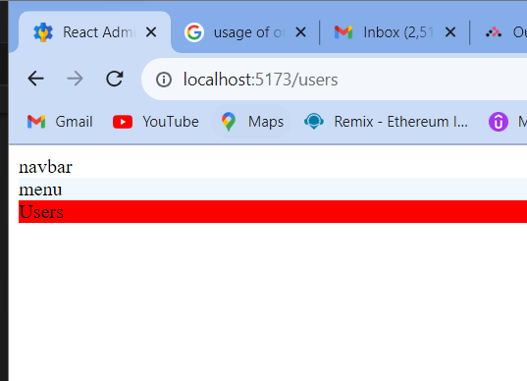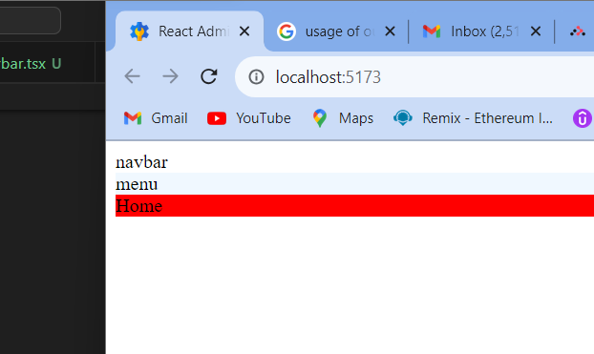

So we can observe here how it works for different routes

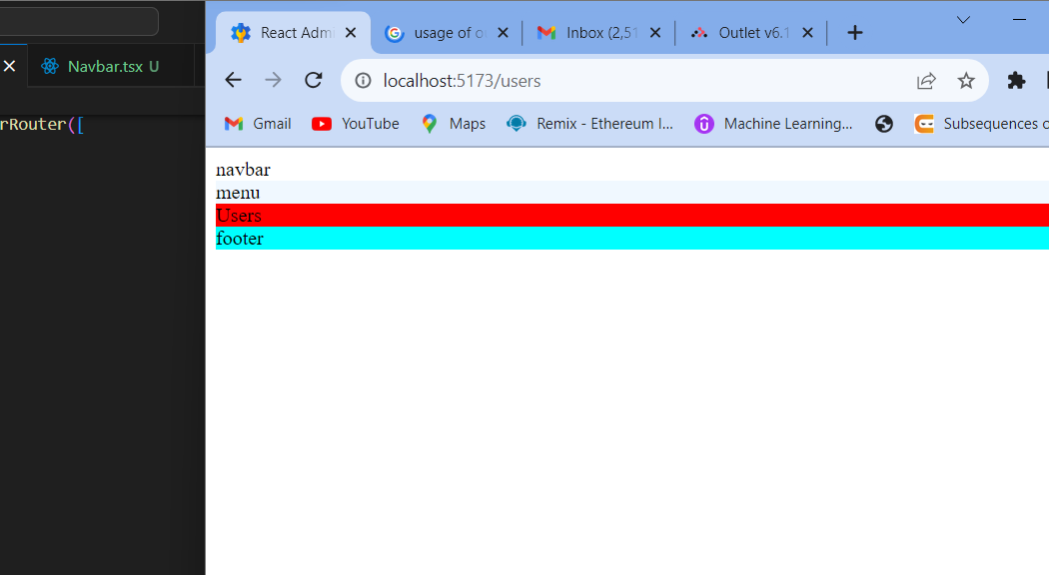

So we have even footer as well now

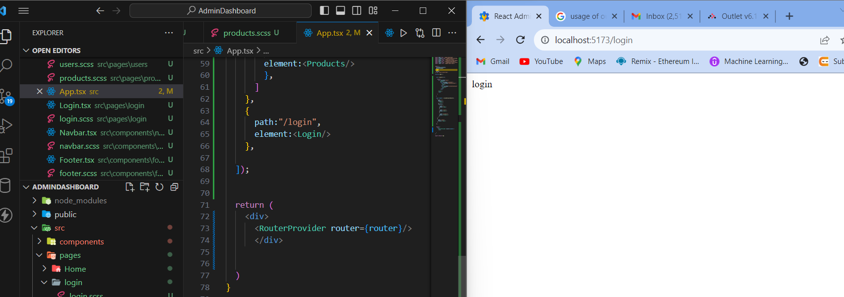

So now for creating a complete new route this process will be used

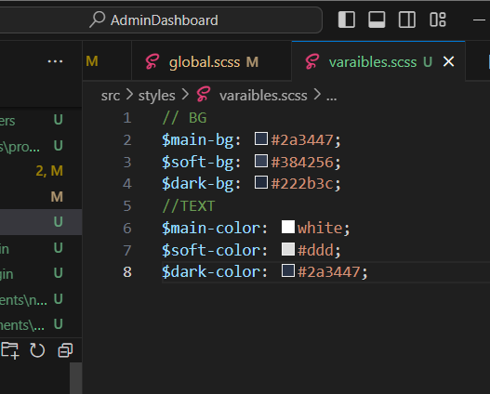

So we created varaibles.scss

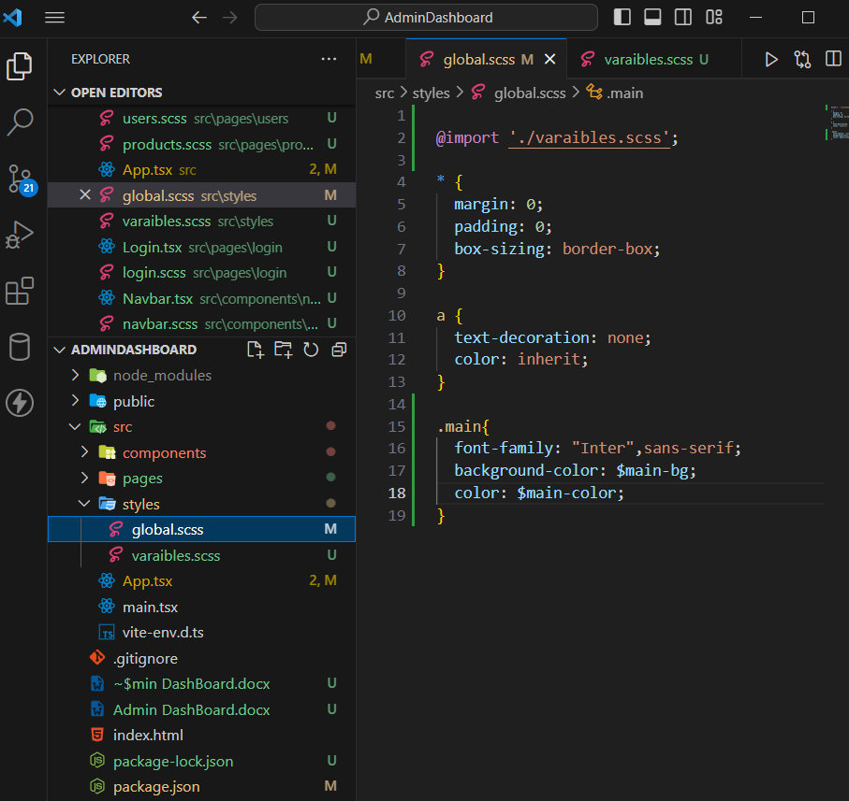

And I have started using it now

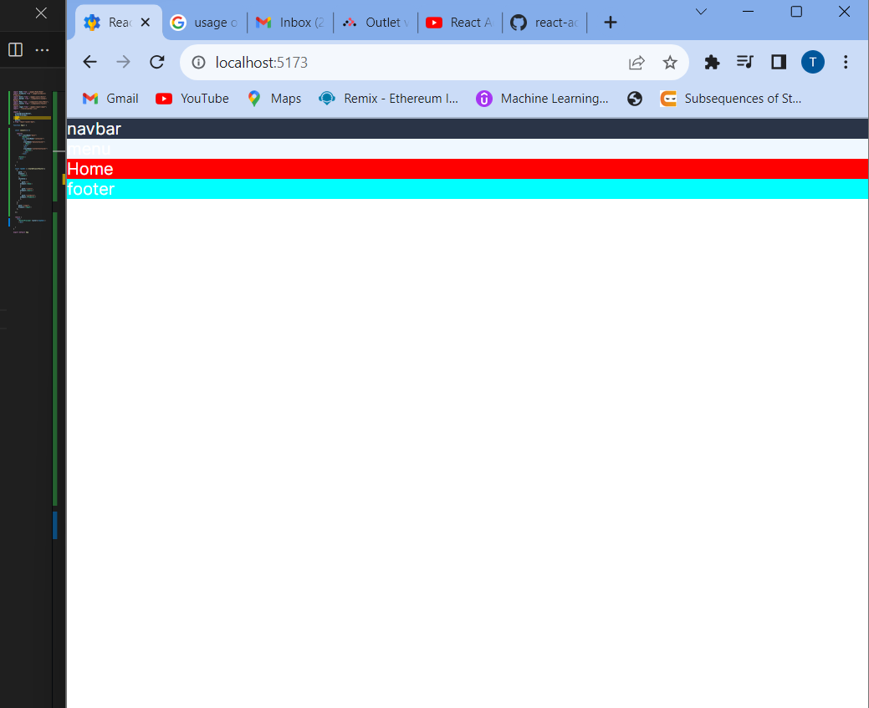

We can observe that css is applied now

**Step 8:**

**Applyiing CSS:**

1)

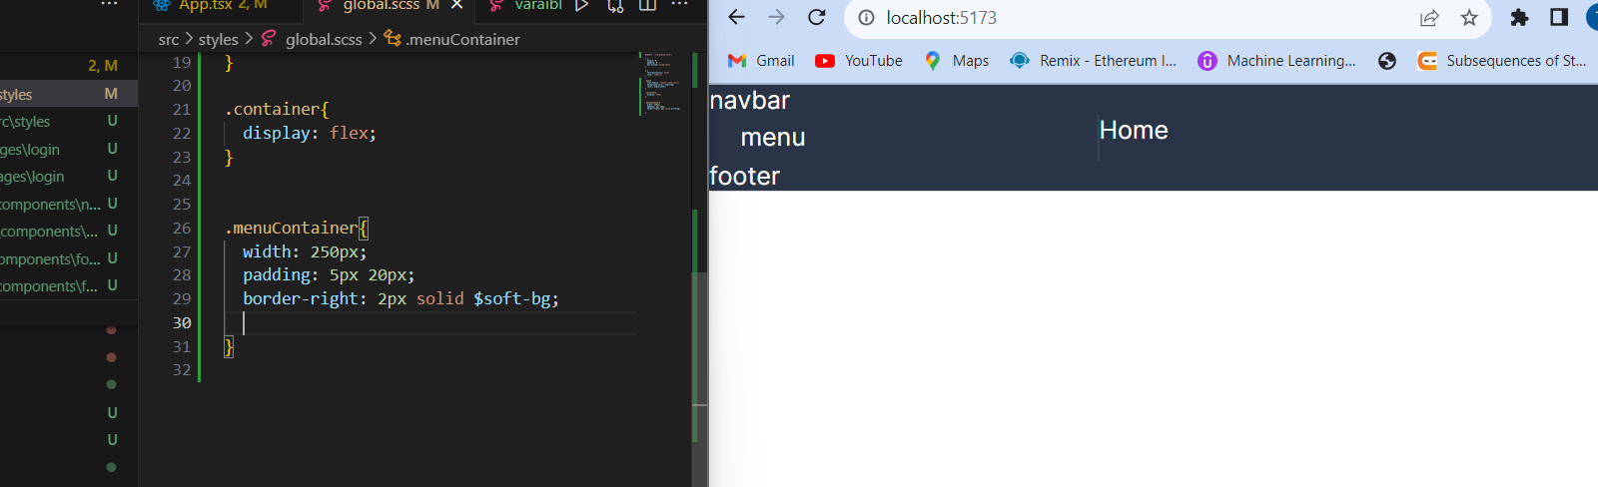

2)

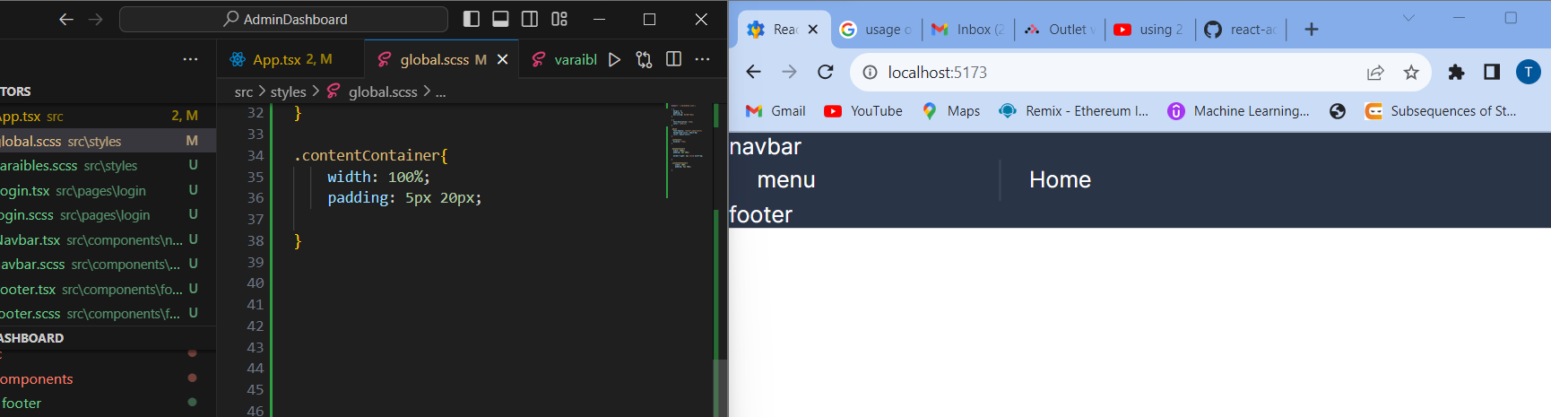

3)Creating and styling navbar

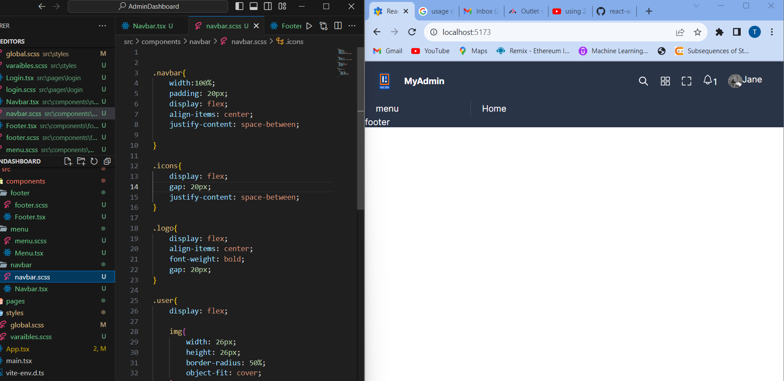

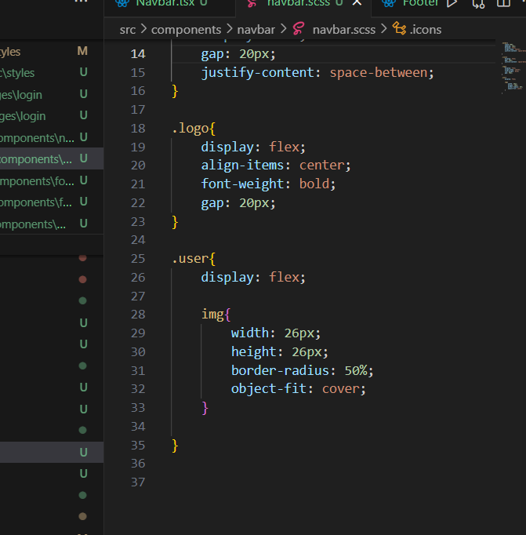

One Challenge:

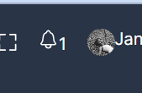

Take this one at top right

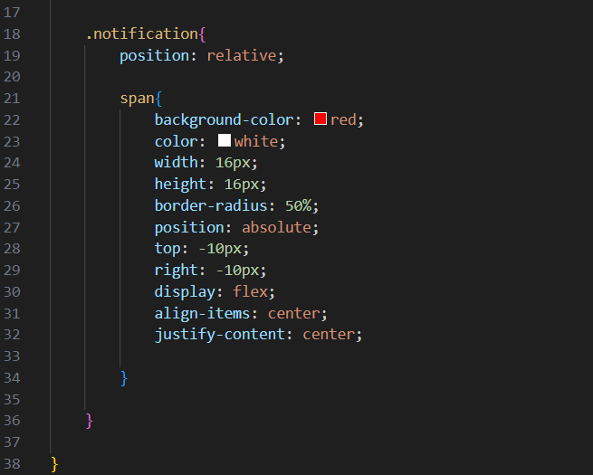

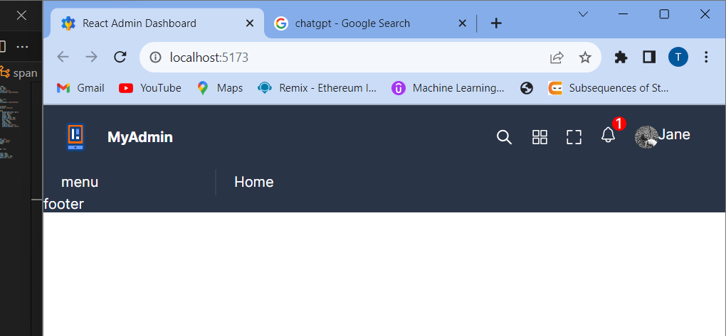

SO now our navbar is ready

4)For footer:

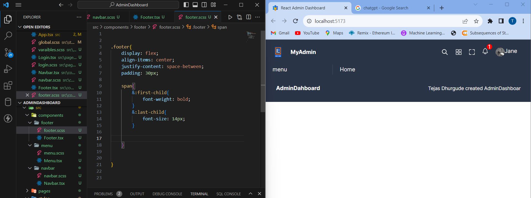

5)Creating a Menu component:

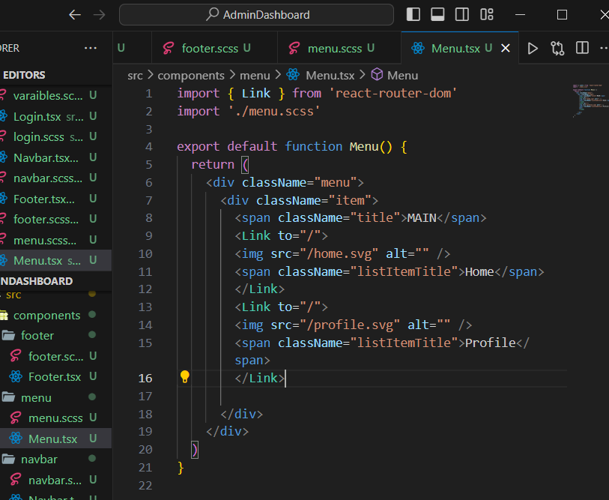

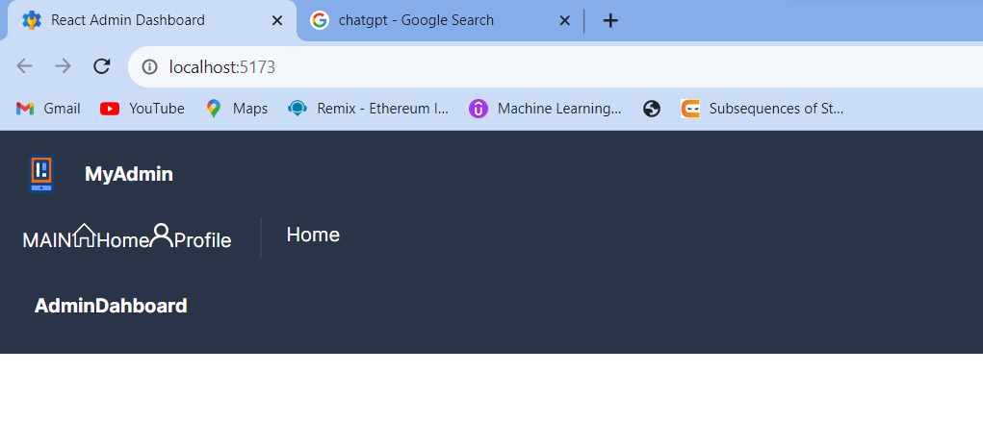Now lets try to apply css to this:

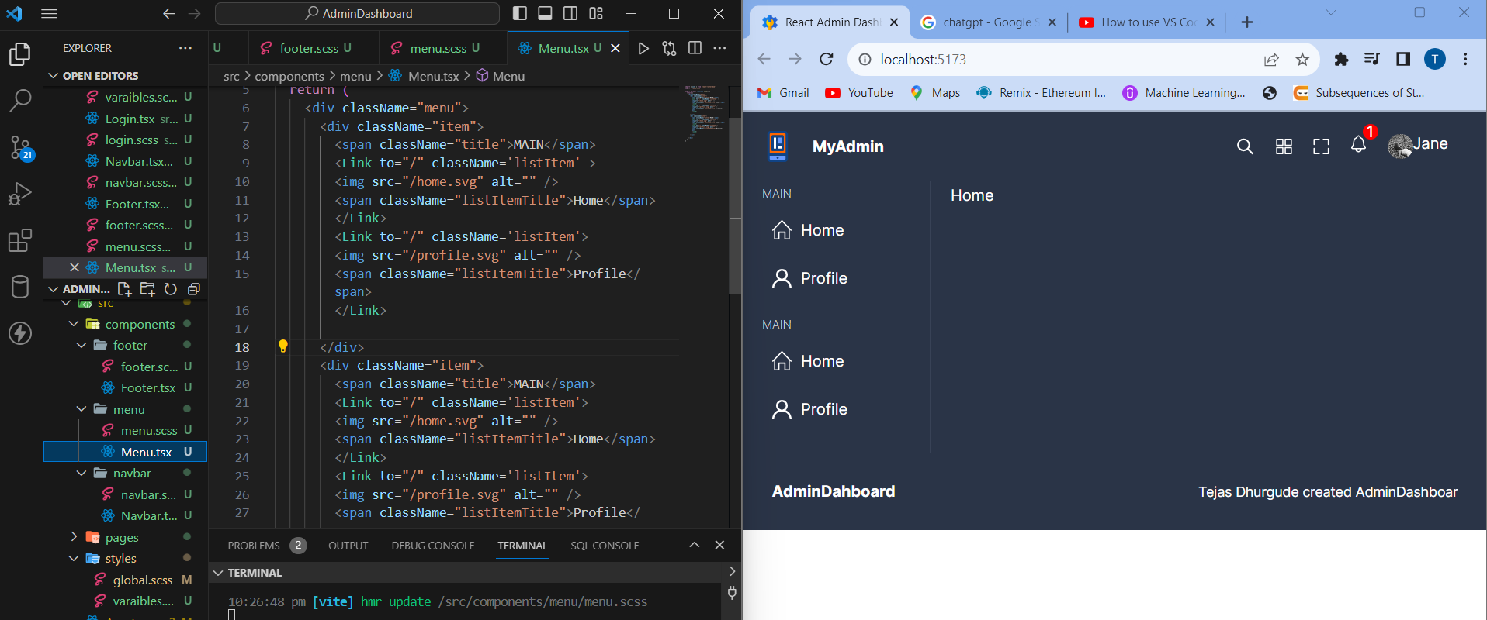

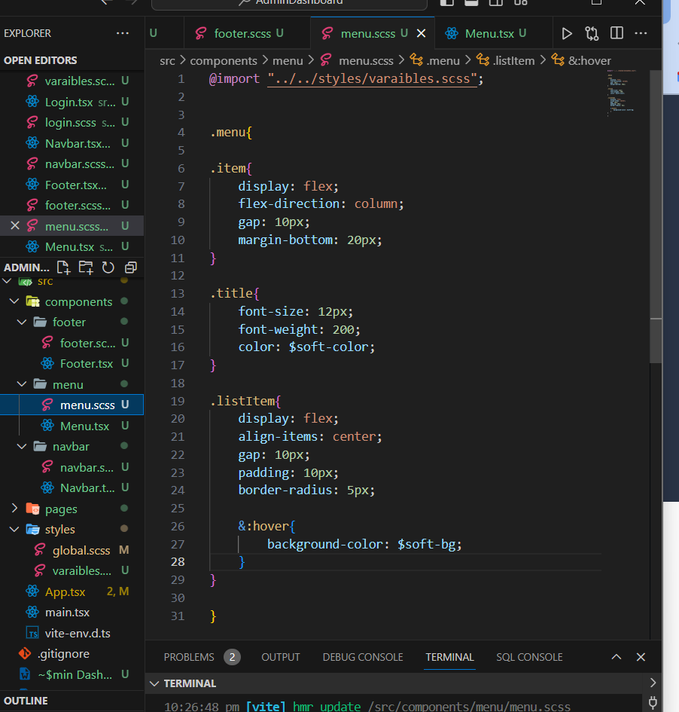

So actually the data is more here so we will use a separate file and fetch data from that file to make our code shorter by length

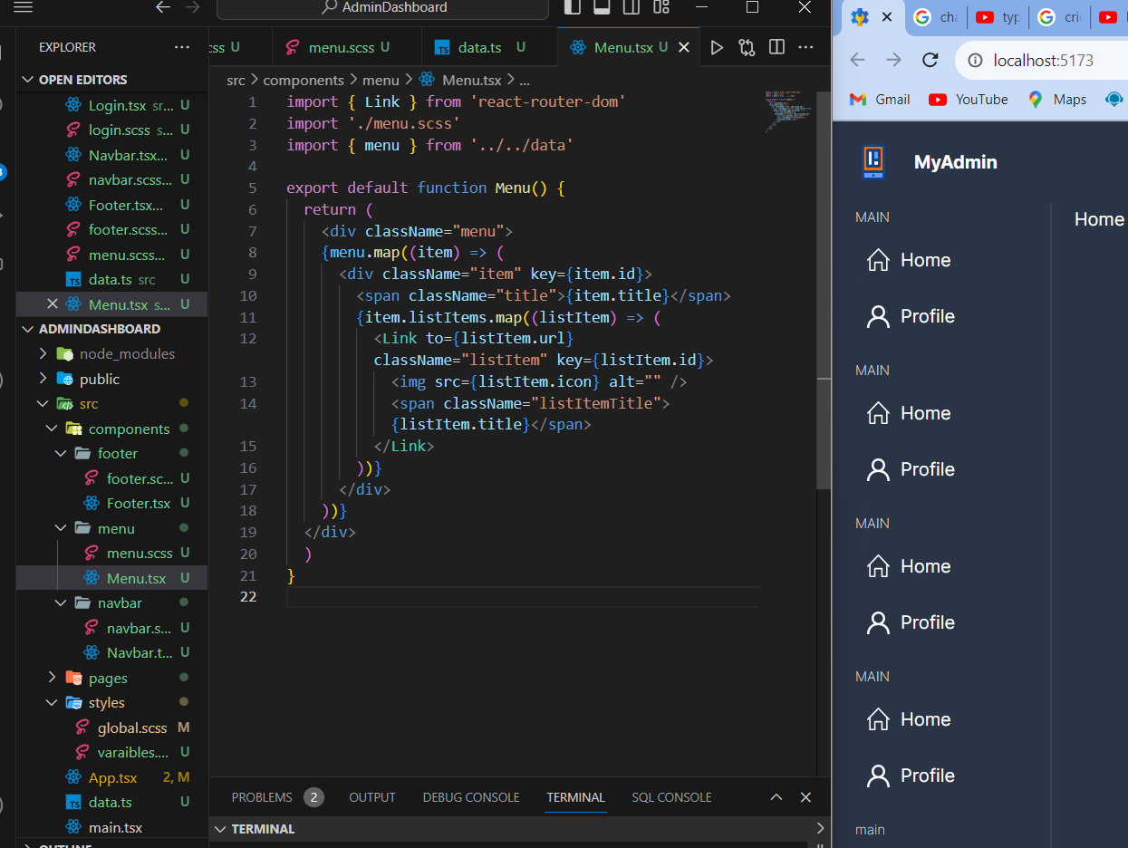

8) Creating a Home page:

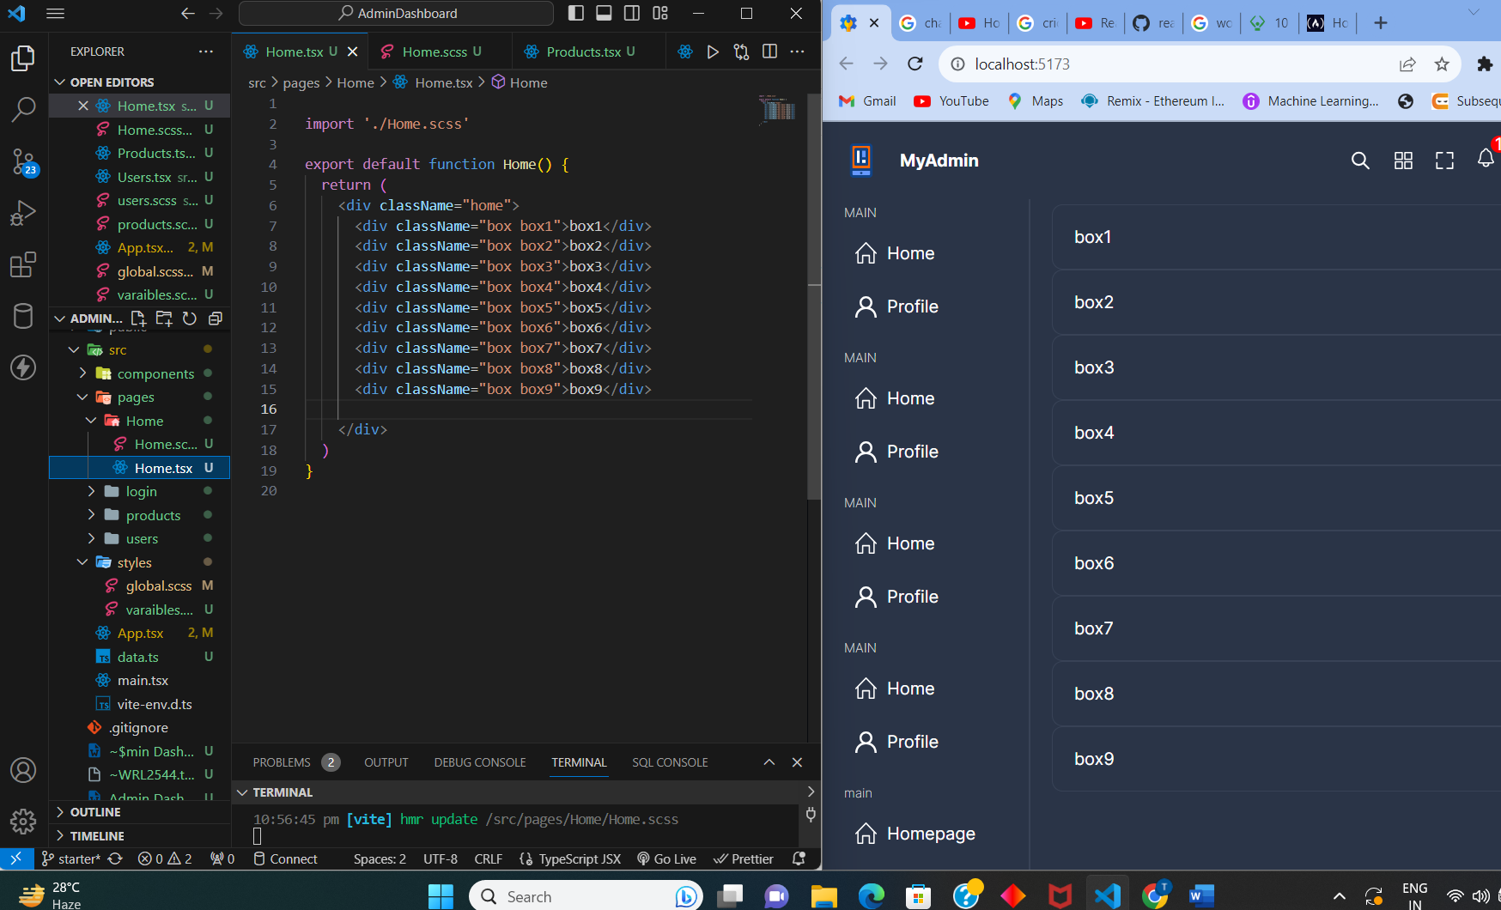

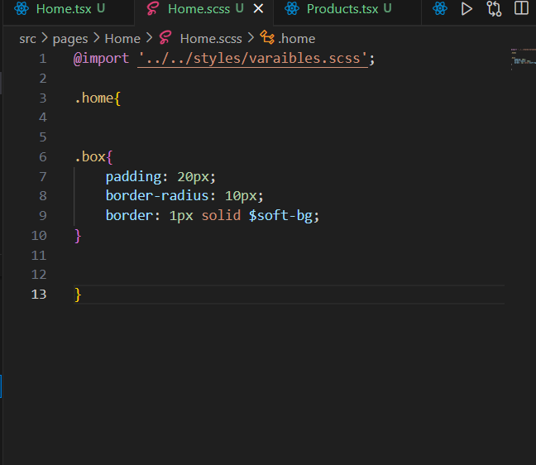

Now we will be applying grid system to this:

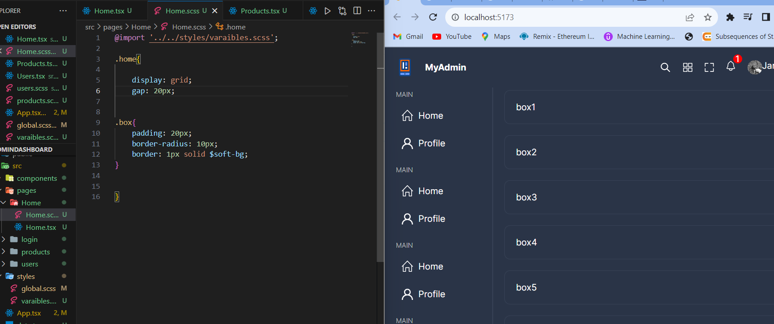

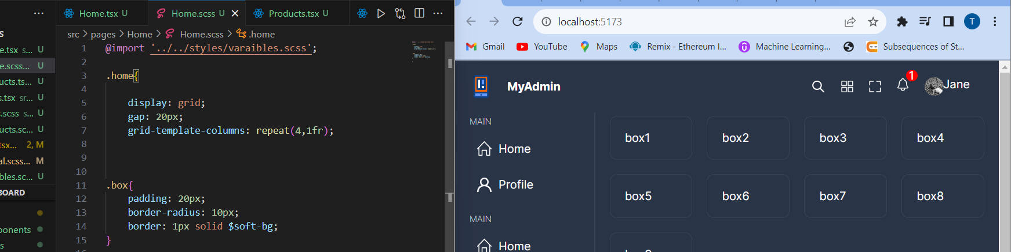

So here in 1 row 4 boxes are fixed now we we have to sort the height but width of 4 were same but the height is varying we will try to sort this out now:

Note:

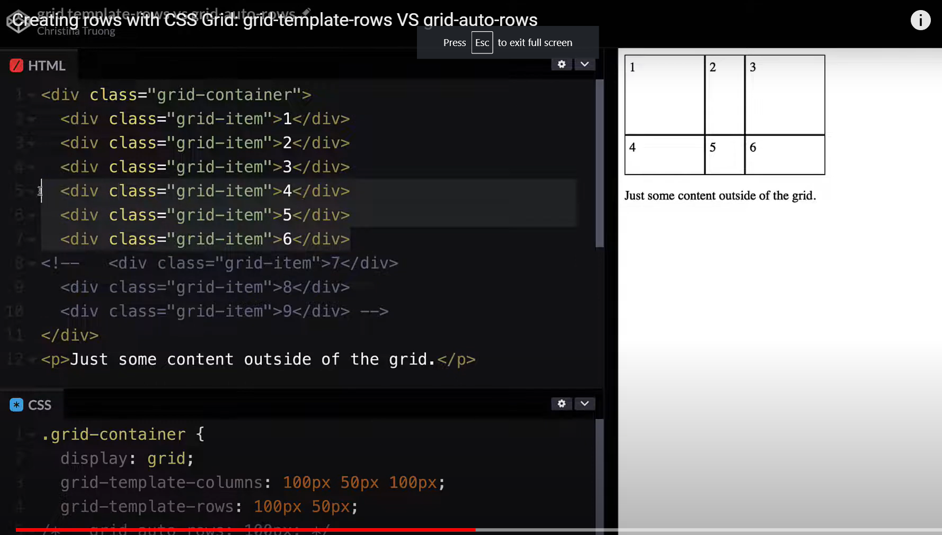

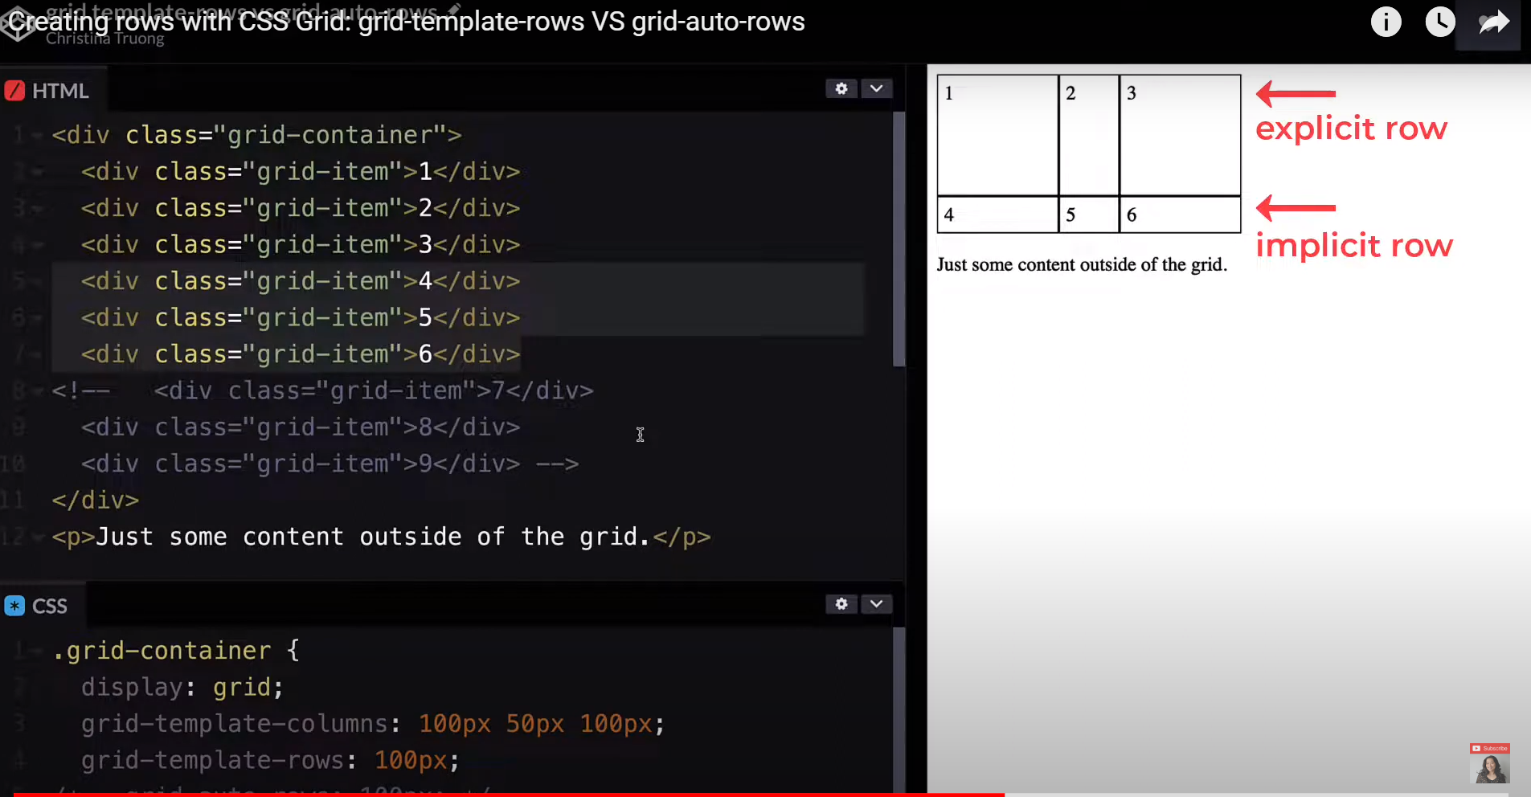

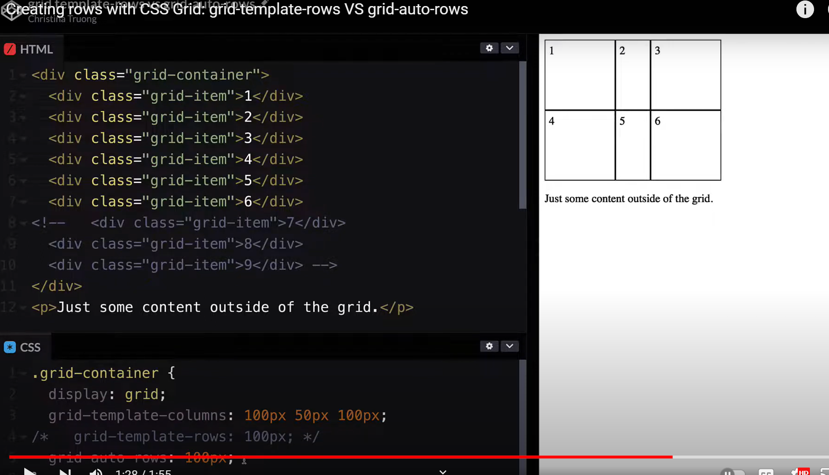

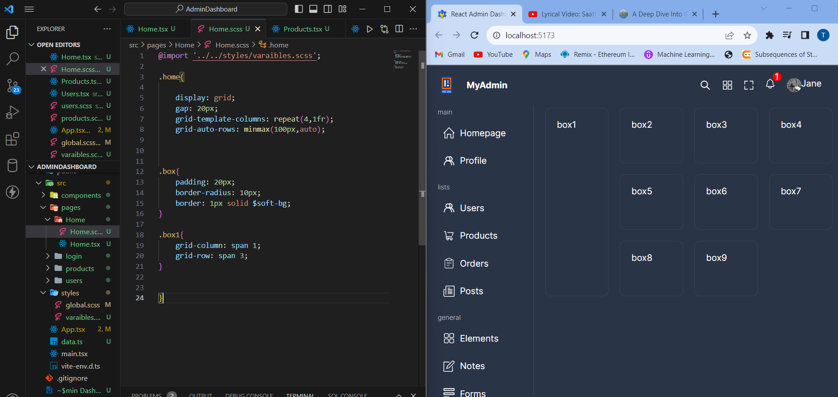

So observe here how we have applied grid-row: span 3

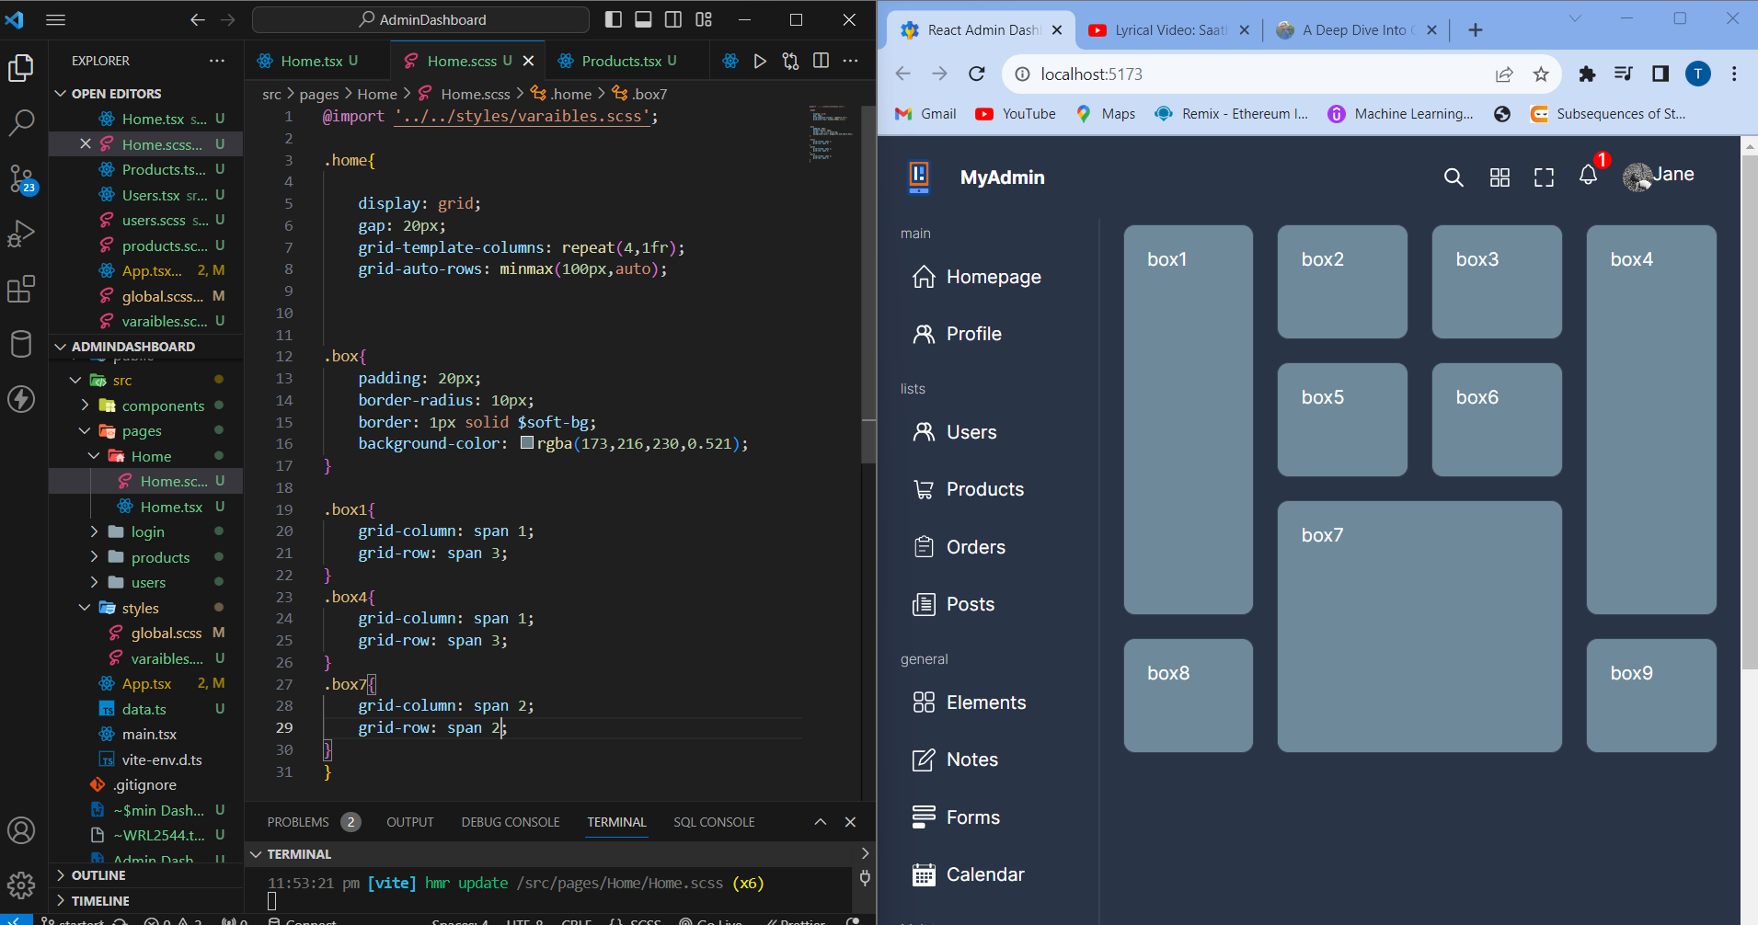

So we can observe how easy it becomes using grid

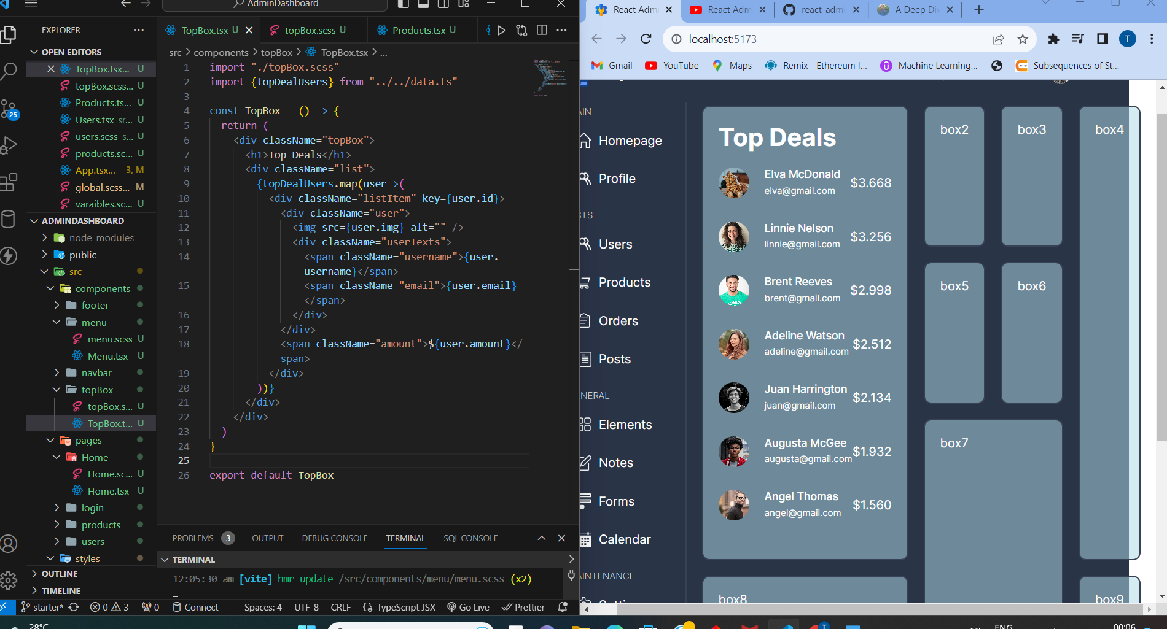

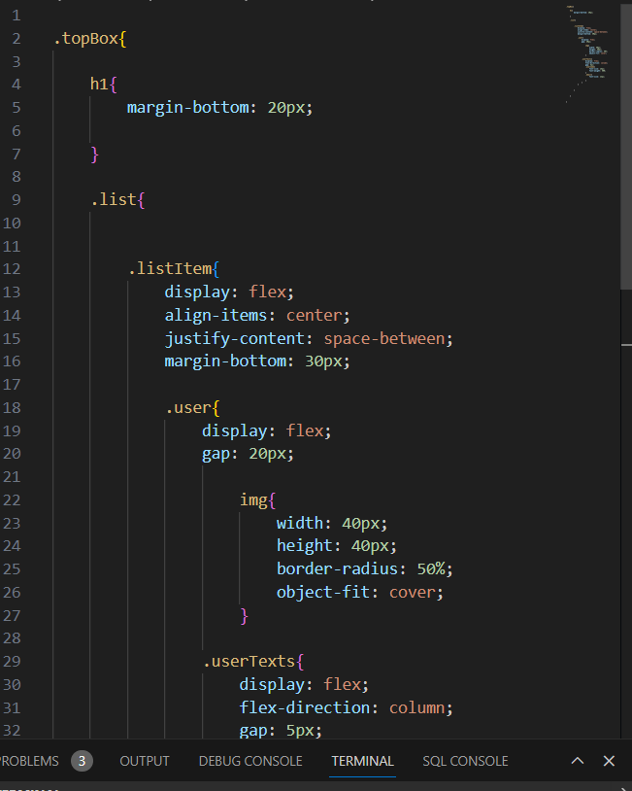

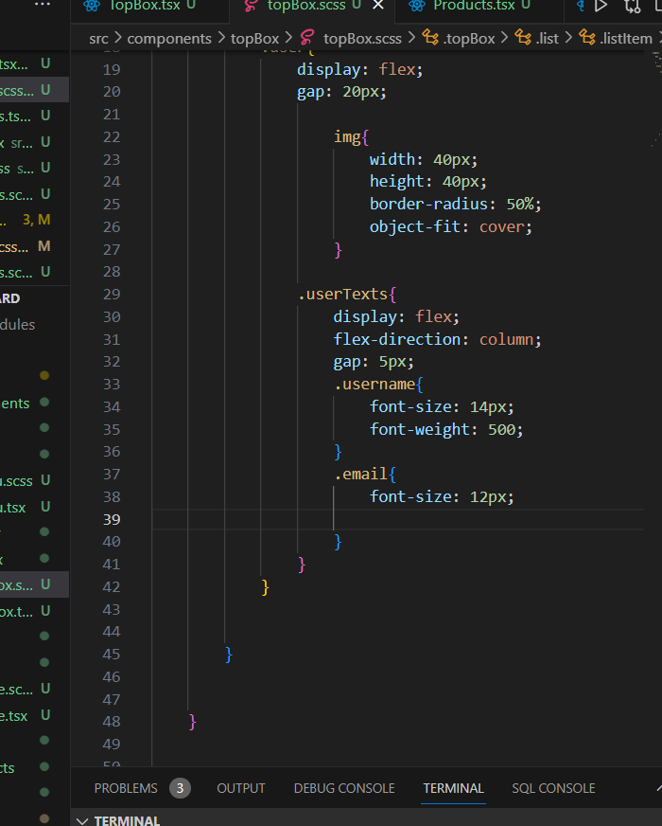

**Step 10:**

**Creating and using ChartBox in react:**

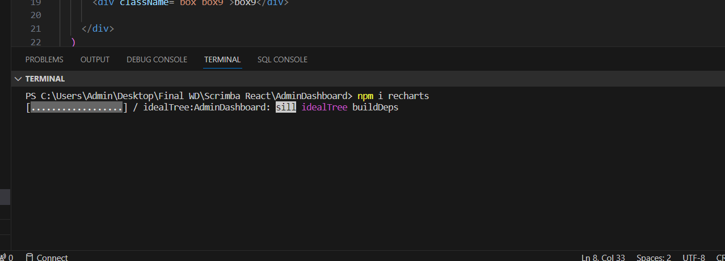

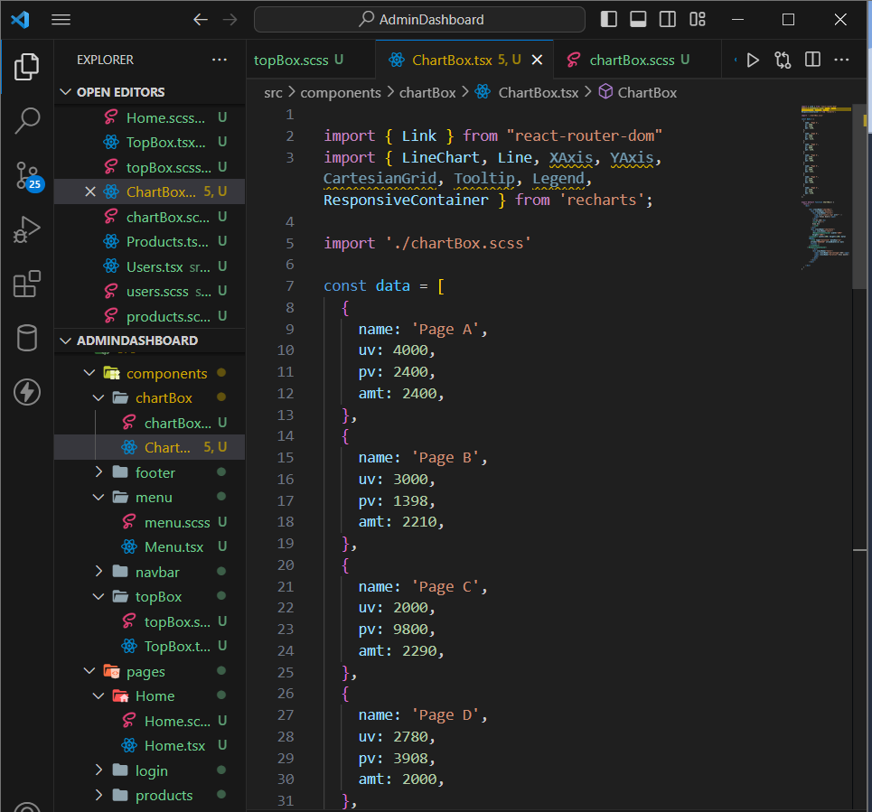

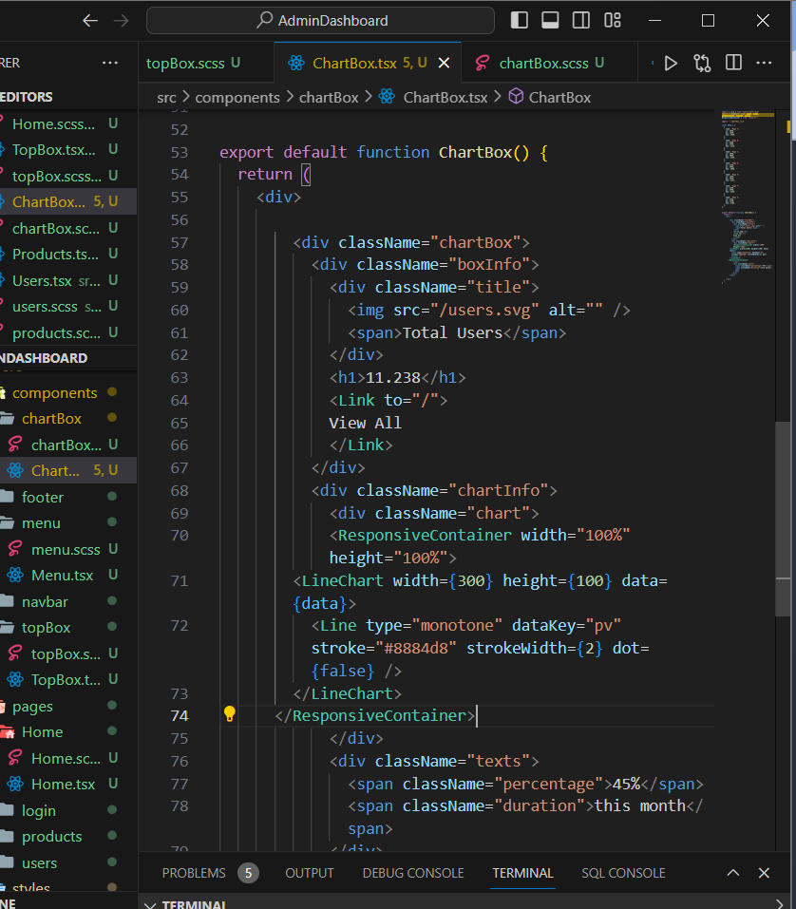

Observe that dot={false} will remove that dot from chart

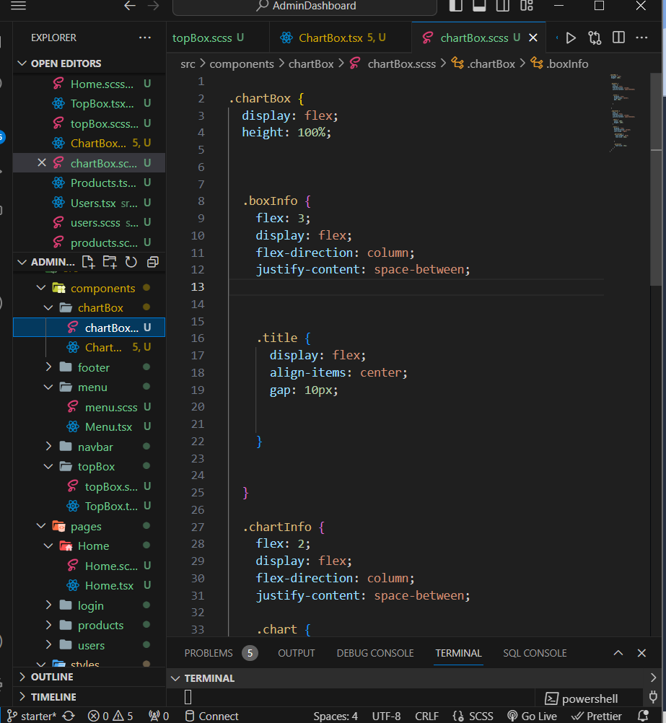

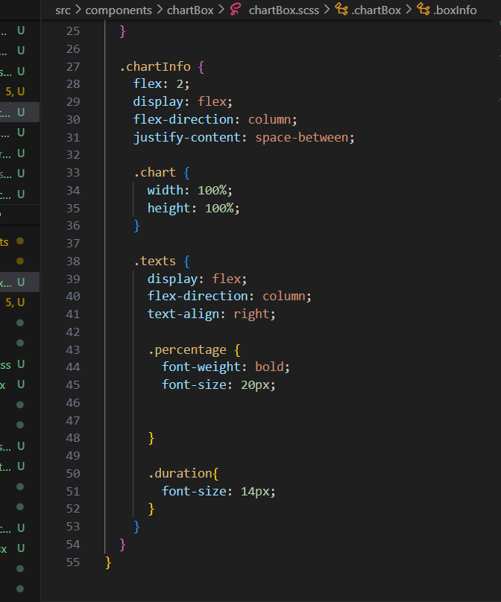

Now actually when we hover over the graph we cannot see the data

So how to see the data

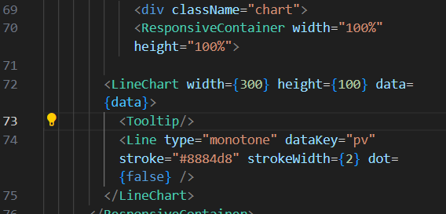

So we have to use tooltip tool but we can view data in different forms in documentation – api- tooltip

We will find all these information

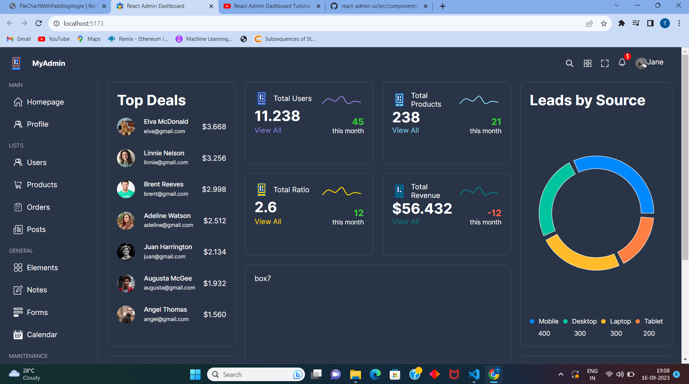

So now similarly we have build our pie chart also

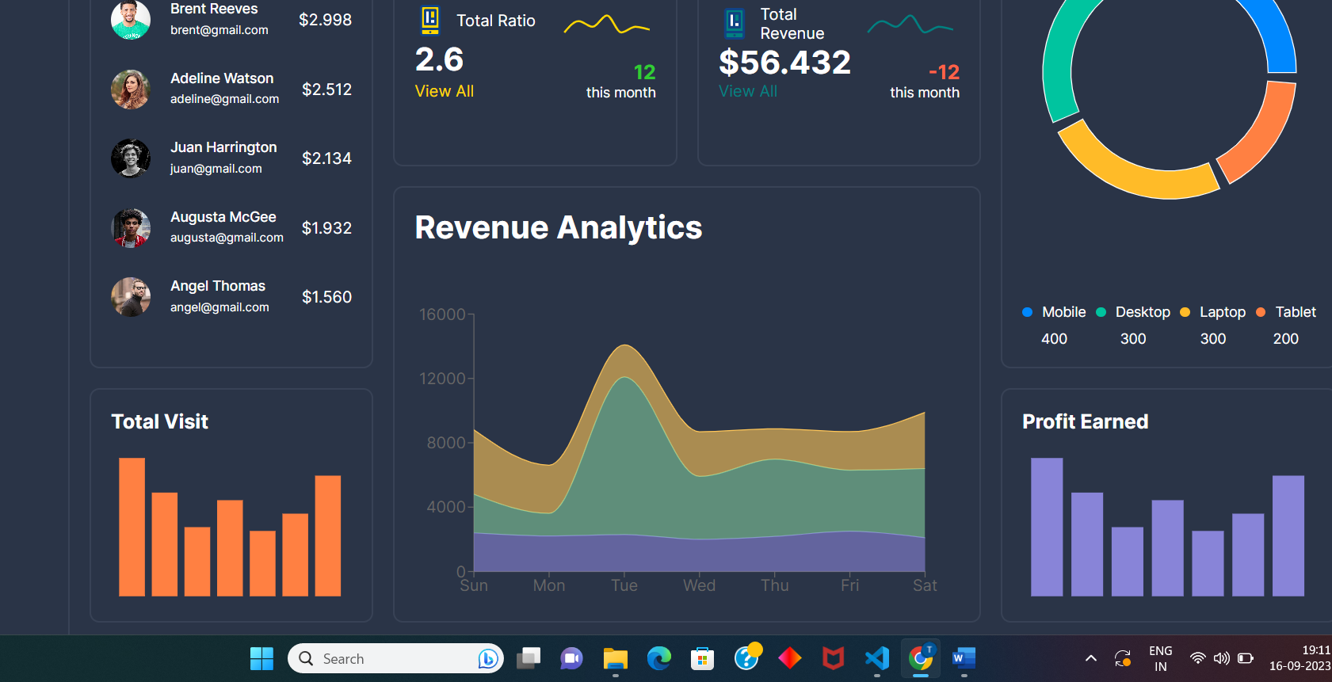

So same goes for revenue analysis as well

**Step 11:**

So now we will be using material ui grid

So after going to mui data grid:

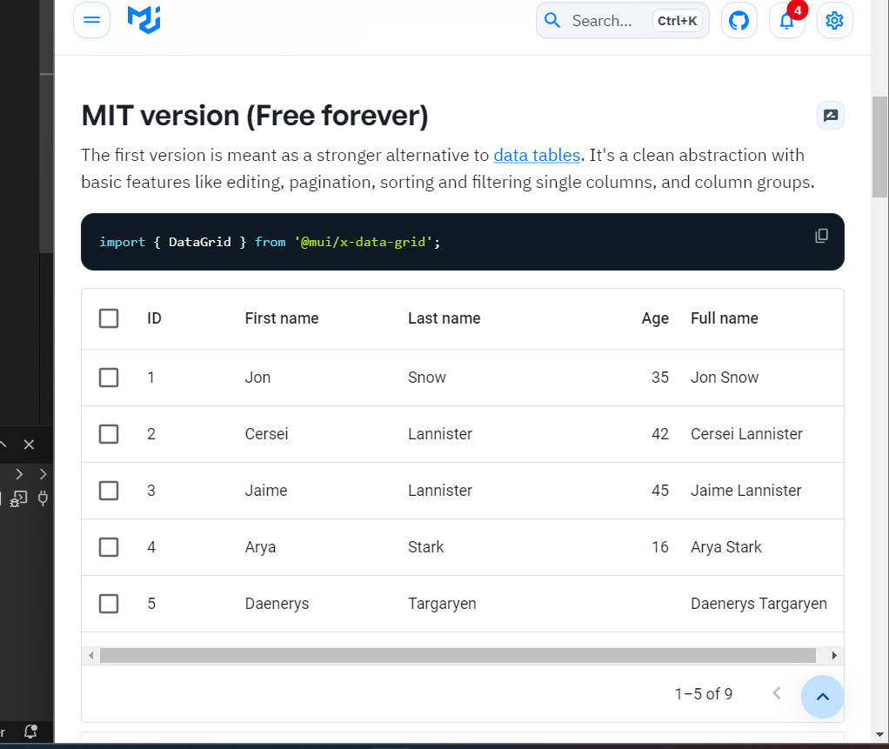

So we will Install it and directly use it in our application

